Adrien Protzel

1. 2. Easier: more redundant paths to a solution 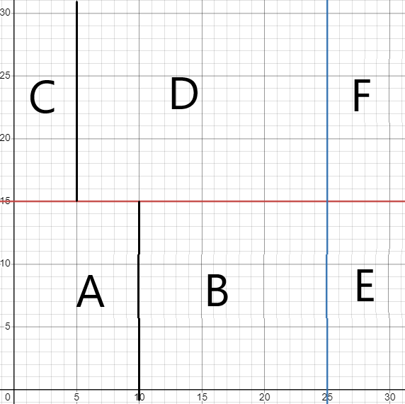allows for worse algorithms to still succeed.

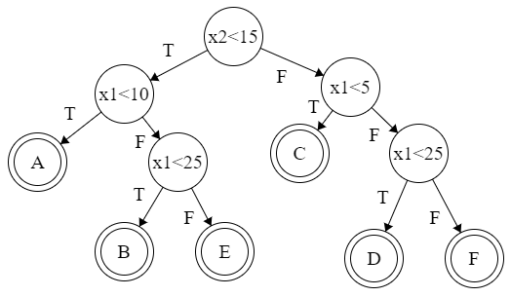



Split on C=0

Split on C=1

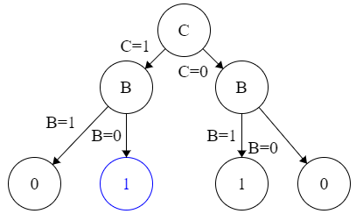

1. 1. 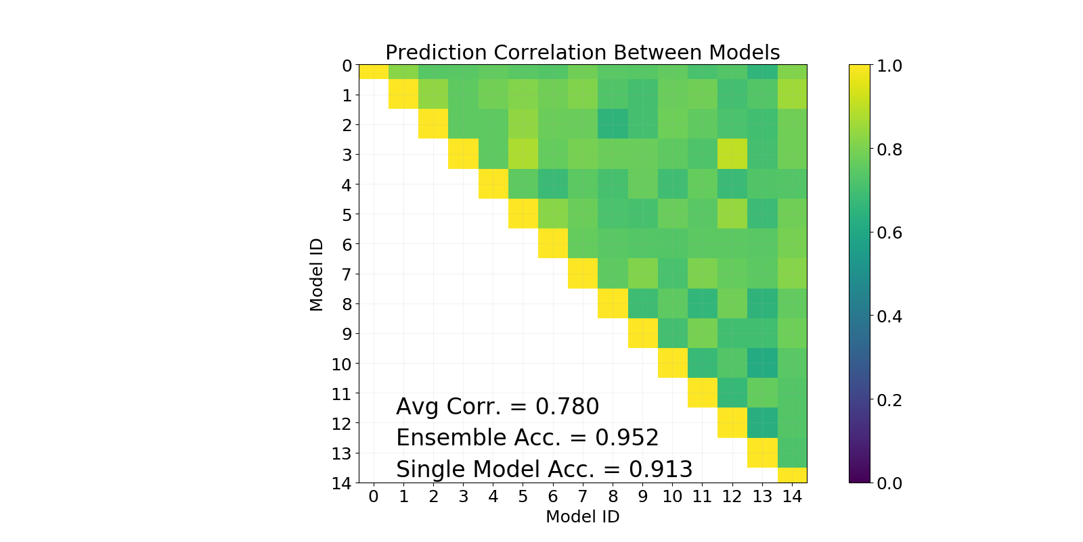Corr is reduced because some samples could have been picked multiple times.

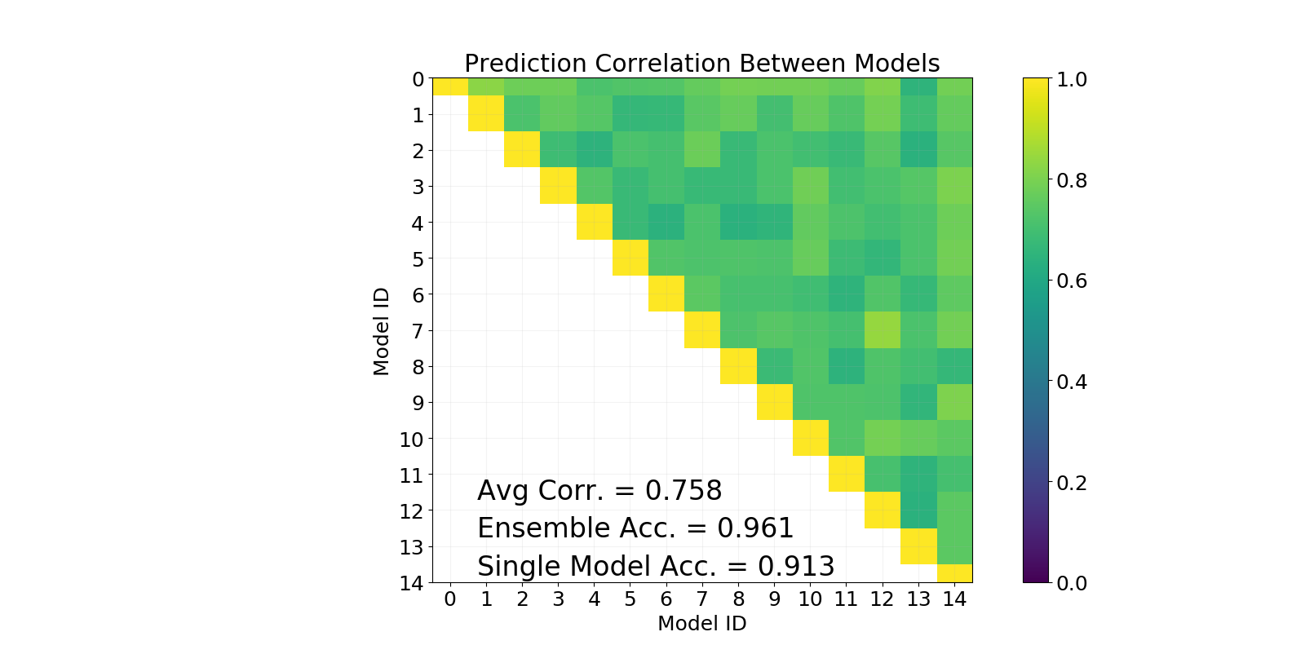

* 1. Setting 9 subsets to be picked by max_features during classifier.

Corr is reduced even more.

1. 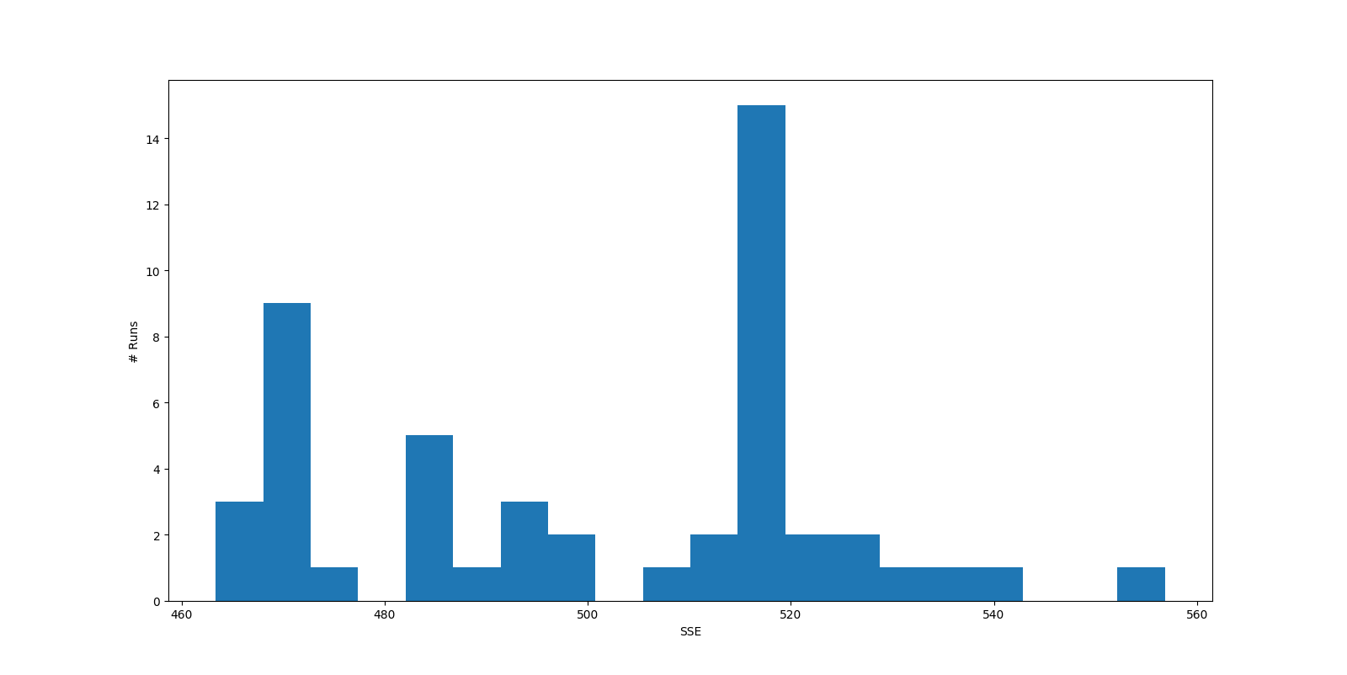-
3. 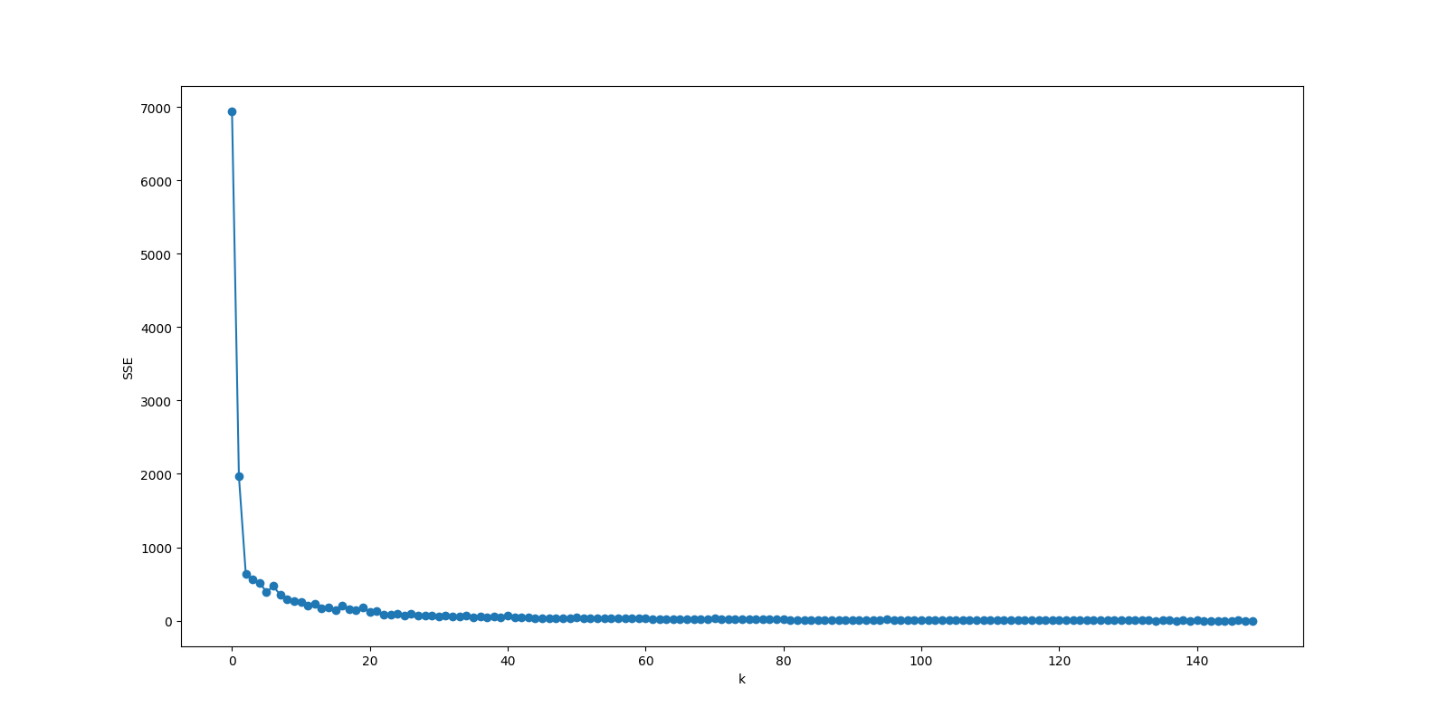
4. 1. Roads, Trees, Buildings, 1 panda (possibly labeled as a building). There are some clusters that have very few images and some with a lot of images. There are also a number or clusters with largely the same images (all buildings).
   2. k=3, good enough to show the three main cluster types
   3. The k=10 had many redundancy cluster images. Since there were three main objects depicted, 3 clusters are all that's really necessary.
5. 1. 1: Roads: 46/50 are Roads
   2. 2: Buildings: 42/50 are Buildings
   3. 3: Trees: 45/50 are Trees
6. About 10 hours
7. Moderate
8. Mostly alone
9. 70%